* First time opening:
  + Asks if there is a GasBuddy account
    - What are the benefits to doing this?
      * Points for reporting prices
      * Challenges
      * Drawings
    - If not there are three options to sign up (Email, Google, Facebook)
      * Can skip!

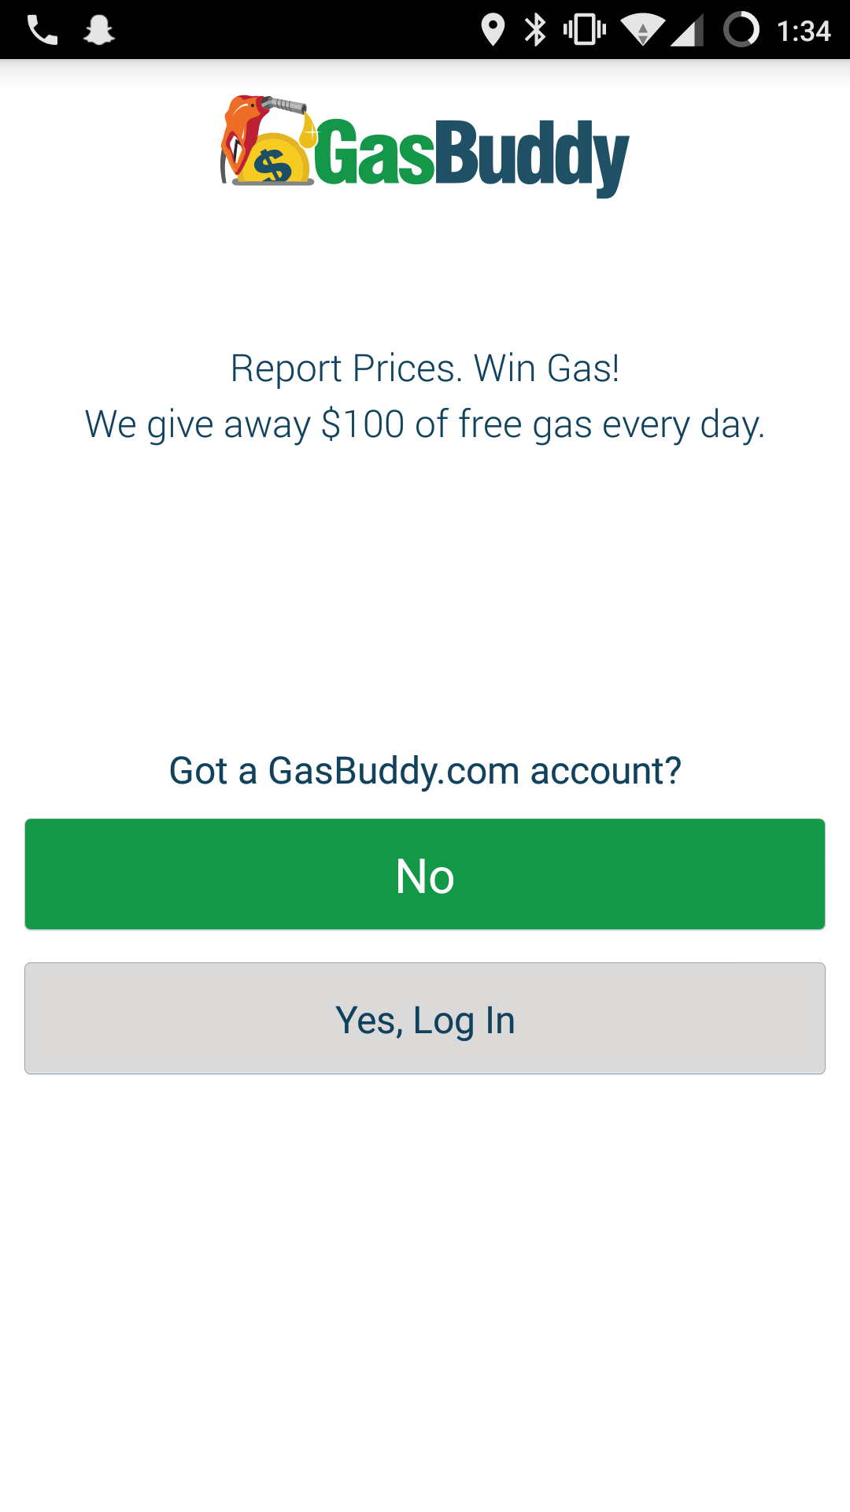

* Homescreen

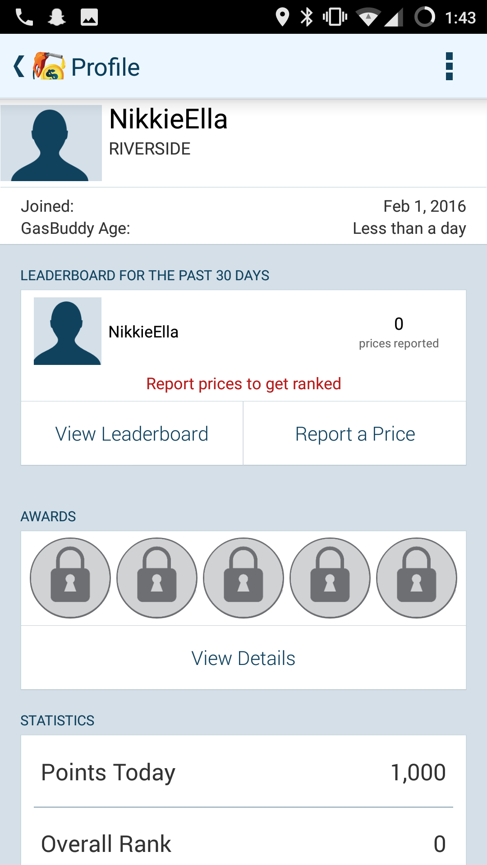

* + Profile on the top left
  + Settings on the top right
  + Search Bar (static and always there)
    - Share GasBuddy
    - Search Preferences
      * Fuel Type
      * Distance
      * Show all stations
    - Members
      * Log In
    - Gasbuddy App
      * App Start up (gives the option to open at a certain screen)
      * Notification
      * Vibration
      * Sound
      * Lock Orientation
      * Clear Search History
  + Button to find “gas near me”
  + Win Gas tab
  + Favorites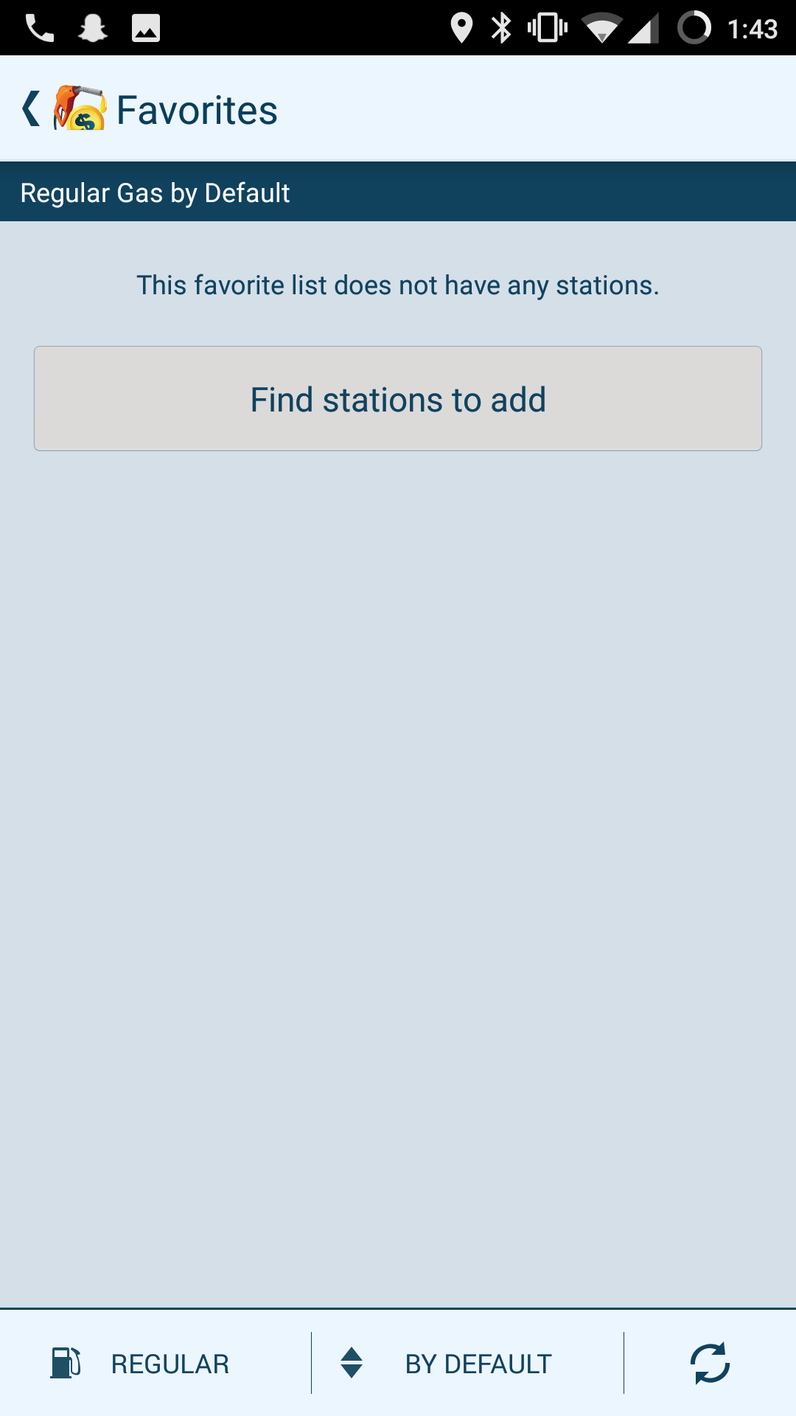

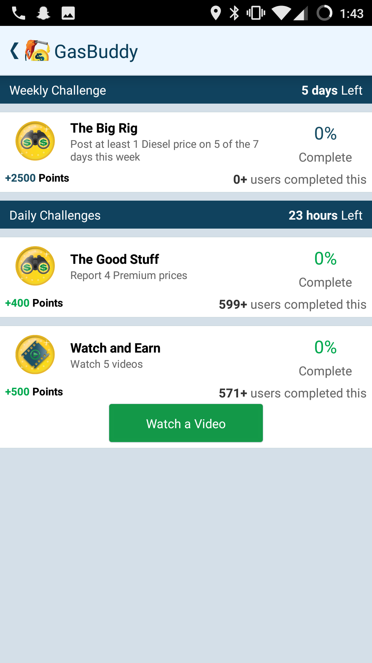

* + Challenges
  + Bottom
    - Has trends of the costs
* Regular Gas Near Me